

A**: PERSONAL PARTICULARS**

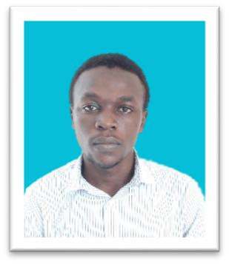SIRNAME: NYEMA

FERST NAME: MUDHIHIR

MIDDLE NAME: HAMIS

AGE: 22

SEX : MALE

MARITAL STATUS: SINGLE

STREET: MANZESE

REGION: DAR ES SALAAM

NATIONALITY: TANZANIA

B: **CONTACT ADDRESS**

Email**: nyemamudhihir@gmail.com**

Mob: +2550682131140

C: **EDUCATIONAL BACK GROUND**

|  |  |  |  |
| --- | --- | --- | --- |
| **YEAR** | **INSTITUTION** | **AWARD** | |
| 2021,Todate | Ardhi University | ---- | |
| 2019,2021 | Bagamoyo Sec High School | Certificate of Advance Education | |
| 2015,2018 | Nachingwea Day Secondary School | Certificate of Secondary Education | |
| 2008,2014 | Ngunichile Primary School | Certificate of Primary Education | |
|  |  |  |  |

D: **WORKING EXPERIENCE**

**July-September 2023 TCB BANK**

* + Application support, user interfaces design and backend implementation.
  + Business solution support, troubleshooting and system debugging.
  + Web and System development.

**September up to currently 2023 AMECORE SOFTWARE COMPANY**

* Web development.
* System development, analyst, design and implementation.
* Mobile development.

1. **LANGUAGE** 
   * English written and well spoken
   * Swahili written and well spoken

1. **KWOLEDGE AND SKILLS** 
   * + Excellent skills of variety of programming languages including Java, python, and Php with Laravel, Javascript, Sql, Mysql, HTML, CSS(Bootstrap, Tailwind), Mobile development (Flutter and java).
     + Java Spring boot development with thymeleaf.
     + Strong troubleshooting skills with software, hardware & Network Products.
     + Communication skills.
     + Project Management.
     + System and Web development.

## G. HOBIES

* Computer programming.
* Football player.
* Creativity in nature.
* Team player.

## H. REFEREES

HAMIS SAID NYEMA, Mob: +2550719802510

DK. EUNICE DAVID, Mob: +2550744170150, Ardhi University lecturer.

Melleji, Mob: +255752 940 816, Amecore software company.

Arthur, Mob: +2550789 287 509,System developer, TCB BANK.

## I.VERIFICATION

I certify that the above information contained in this document correctly described my qualification and myself only.

**Signature M. H. Nyema.**